C.Cooper: Condensed Birkman

General Interest

Typical activities include:

• planning

• dealing with abstraction

• thinking of new approaches

• innovating

• working with ideas

Likes to:

• innovate or create

• plan how to do things

• consider the future

• create new approaches

• look at things theoretically

General Style

Typically:

• insightful

• selectively sociable

• thoughtful

• reflective

• optimistic

Generally:

• insightful

• optimistic

• thoughtful

• selectively sociable

• reflective

General Stressors

Typical behaviors:   
• dominating

• self-protective

• easily distracted

• disorganized

• driven

• strong-willed

• high expectations

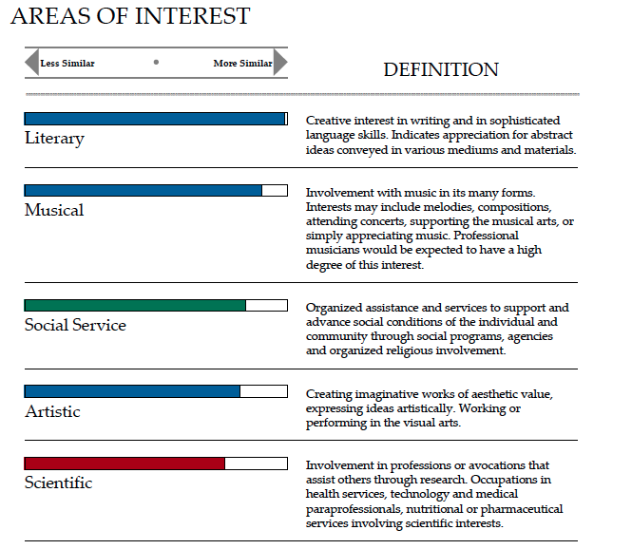

General Strengths

• unevasive

• matter-of-fact

• frank and open

• direct and straightforward

• independent by nature

• able to be and work alone

• withstands group pressure

• balances structure and flexibility

• combines action and planning

• self-starting, but adaptable

• authoritative, yet pleasant

• open to discussion

• self-directive

General Needs

**• others to be frank and forthright**

POSSIBLE STRESS REACTIONS WHEN NEEDS ARE NOT MET:

• too much independence

• withdrawal

• impatience with group dynamics

• resistance to routine

• weakened follow-through

• neglect of order and system

• discouragement

• loss of energy

• experiencing tedium • annoyance at delays

• problems with self-discipline

• inability to concentrate

• unnecessary worry about decisions

• impulsivity

More than most people, you tend to focus on your personal shortcomings rather than your strengths. As a result, you

are able to take a great deal of pride in your accomplishments, and respond well to difficult or demanding tasks and goals.